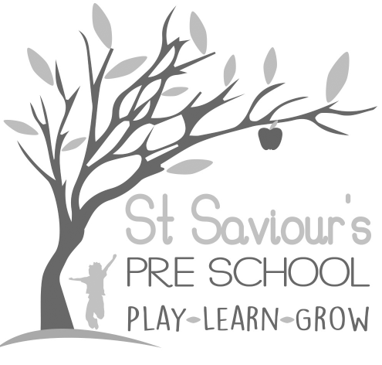
6.5 FOOD AND DRINK

Written by: Claire Toms and Tina Alder Date: 1.09.22 – reviewed 28.8.25

Policy Statement
We consider snack and mealtimes an important part of our day, providing opportunities for social interaction between children and adults, and helping children to learn about healthy eating. Children are provided with healthy snacks including fruit, raw vegetables (carrots, cucumber, peppers), salad, toast, and occasionally biscuits. They are allowed water or milk to drink.
Children may ask a member of staff for a drink whenever they wish, and tap water is always available in the hall and in the garden on warm days. Staff encourage children to take regular drinks to support hydration, in line with EYFS 2025 guidance.
We follow the EYFS 2025 guidance that treats and foods high in sugar are given only occasionally and not as a regular part of the daily menu. Sugary drinks, sweets, chocolate bars, and other high-sugar items are not provided in the setting.

Procedures
We follow these procedures to promote healthy eating in our setting:
- Dietary requirements, allergies, and intolerances are recorded on registration forms, in Learning Journals, and on the kitchen notice board. Staff must consult this information before any cooking activities, food tasting, or snack provision.
- For children on a special diet (e.g., wheat-free, dairy-free), parents are asked to provide a named snack, stored in a clearly labelled box in the medical cupboard.
- Anaphylaxis: Training is provided for all staff before the child begins at the setting, and this training is reviewed at the start of each term in line with EYFS 2025 requirements. The child’s EpiPen, photo, emergency contact numbers, and a pen are kept in a labelled box in the medical cupboard with clear instructions for use.
- We organise lunch and snack times as social occasions, encouraging children and adults to participate together.
- To reduce the risk of choking: Snacks such as grapes, cherry tomatoes, olives, raw carrots, cucumber sticks, and other raw vegetables should be cut into small pieces (quartered or chopped as appropriate). Nuts, whole grapes, whole cherry tomatoes, marshmallows, and other high-choking-risk foods must not be provided.
- Sugary foods and drinks are strictly limited. Treats such as biscuits are occasional, not daily, and never in place of fruit or vegetables. Sugary drinks are not permitted; water and milk are always available.
- Parents are advised on healthy foods to include in lunch boxes and must not send sweets or nut-containing products. Children are encouraged to develop independence in organising their lunches and making healthy choices.
- To protect children with food allergies, we discourage children from sharing or swapping food with one another. Staff supervise snack and lunch times closely to ensure compliance with individual dietary requirements, allergy plans, and EYFS 2025 guidance on allergen management.
- Staff ensure that any cooking or tasting activities use only ingredients checked against children’s allergy records, with separate utensils and surfaces cleaned thoroughly to prevent cross-contamination.
- A member of staff who holds a valid and current Paediatric First Aid (PFA) certificate must be present in the room whenever children are eating and must be within sight and hearing of the children at all times.
- During all snack and mealtimes, staff will sit with the children to encourage social interaction, model healthy eating habits, and ensure close supervision to prevent choking and food sharing.
- Where possible, staff will sit facing the children while they eat to monitor for choking risks and observe for any signs of an allergic reaction.

